Week 1 Penetration Testing Report
Full Name: Atharva Jagdale
Program: HCPT
Date: 15-02-2025

Introduction
This report document hereby describes the proceedings and results of a Black Box security assessment conducted against Week 1 Labs. The report hereby lists the findings and corresponding best practice mitigation actions and recommendations.
- Objective
The objective of the assessment was to uncover vulnerabilities in the Week 1 Labs and provide a final security assessment report comprising vulnerabilities, remediation strategy, and recommendation guidelines to help mitigate the identified vulnerabilities and risks during the activity.
- Scope
This section defines the scope and boundaries of the project.
{HTML Injection}, {Cross-Site Scripting}
Application Name
- Summary
Outlined is a Black Box Application Security assessment for Week 1 Labs.

Total number of Sub-labs: 17 Sub-labs

High | Medium | Low
4 | 5 | 8

High - Number of Sub-labs with hard difficulty level Medium - Number of Sub-labs with medium difficulty level, Low - Number of Sub-labs with Easy difficulty level

  - HTML Injection
    - HTML’s are easy!

Reference | Risk Rating
Sub-lab-1: HTML’s are easy! | Low
Tools Used
Google chrome
Vulnerability Description
HTML injection is a type of web security vulnerability that allows an attacker to inject malicious HTML code into a webpage. This can occur when user input is not properly validated or sanitized before being included in the webpage's output. Attackers can exploit HTML injection vulnerabilities to manipulate the appearance or functionality of the webpage, steal sensitive information such as login credentials or session cookies, or redirect users to malicious websites. This type of vulnerability can have serious consequences and requires proper input validation and output encoding to mitigate the risk.
How It Was Discovered
I found this vulnerability by using basic HTML tags i.e., h1 tag.
Vulnerable URLs
https://labs.hacktify.in/HTML/html_lab/lab_1/lab_1.php
Consequences of not Fixing the Issue
This can lead to managing and accessing other web pages and it can lead to phishing other users.
Suggested Countermeasures
- Comprehensive Input Validation and Sanitization
- Proper Output Escaping to Prevent Code Execution
- Educate developers on secure coding practices.
- Regularly audit and test for vulnerabilities.
References
- https://www.acunetix.com/vulnerabilities/web/html-injection/
- https://owasp.org/www-project-web-security-testing-guide/latest/4-Web_Application_Security_Testing/11-Client-side_Testing/03-Testing_for_HTML_Injection
- https://www.imperva.com/learn/application-security/html-injection/
Payload Used
<h1>Hello bunny</h1>

Proof of Concept

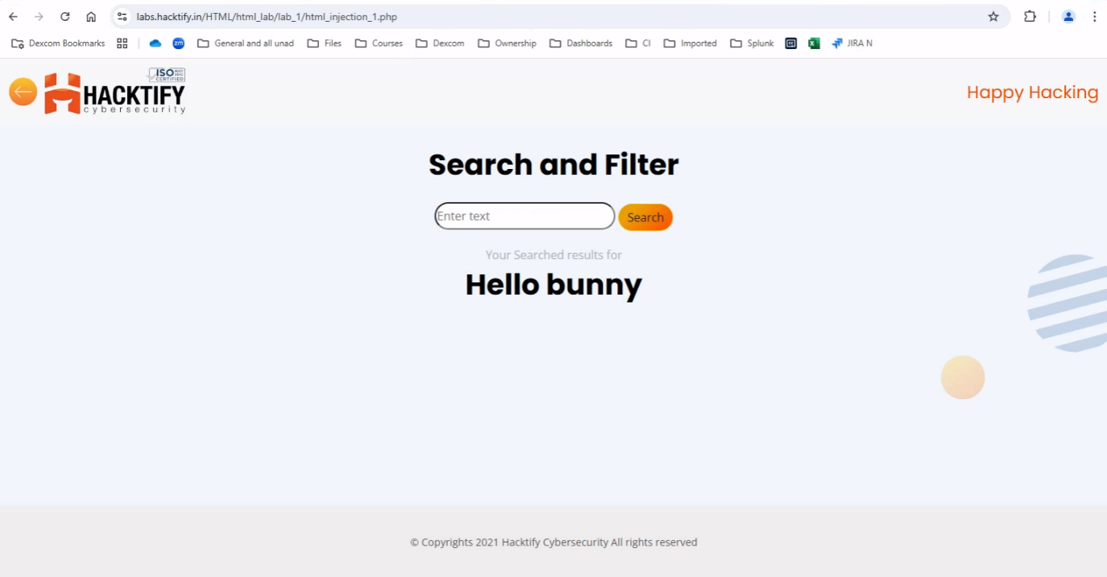
This section contains the proof of the above vulnerabilities as the screenshot of the vulnerability of the lab

    - Let me store them

Reference | Risk Rating
Sub-lab-2: Let me store them | Low
Tools Used
Google chrome
Vulnerability Description
HTML injection is a type of web security vulnerability that allows an attacker to inject malicious HTML code into a webpage. This can occur when user input is not properly validated or sanitized before being included in the webpage's output. Attackers can exploit HTML injection vulnerabilities to manipulate the appearance or functionality of the webpage, steal sensitive information such as login credentials or session cookies, or redirect users to malicious websites. This type of vulnerability can have serious consequences and requires proper input validation and output encoding to mitigate the risk.
How It Was Discovered
I found this vulnerability by trying multiple HTML tags on different input fields. Here, I can run
every HTML valid code to inject malicious code.
Vulnerable URLs
https://labs.hacktify.in/HTML/ html_lab/lab_2/lab_2.php
Consequences of not Fixing the Issue
Can steal another person's identity.
Suggested Countermeasures
- Comprehensive Input Validation and Sanitization
- Proper Output Escaping to Prevent Code Execution
- Educate developers on secure coding practices.
- Regularly audit and test for vulnerabilities.
References
- https://www.acunetix.com/vulnerabilities/web/html-injection/
- https://owasp.org/www-project-web-security-testing-guide/latest/4-Web_Application_Security_Testing/11-Client-side_Testing/03-Testing_for_HTML_Injection
- https://www.imperva.com/learn/application-security/html-injection/
Payload Used
"><h1>Hello Bunny</h1>

Proof of Concept

This section contains the proof of the above vulnerabilities as the screenshot of the vulnerability of the lab
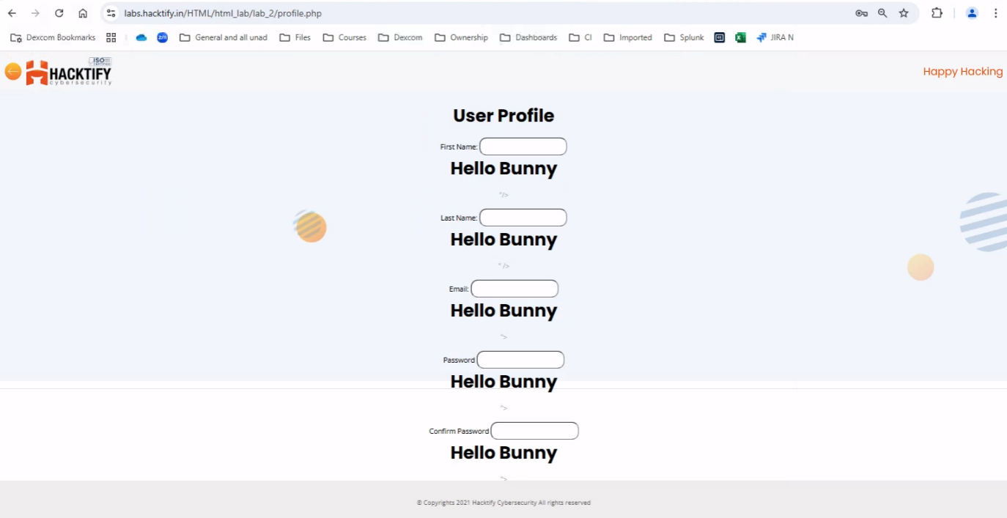
    - File names are also vulnerable

Reference | Risk Rating
Sub-lab-3: File names are vulnerable | Low
Tools Used
Google chrome and Burp Suite
Vulnerability Description
HTML injection is a type of web security vulnerability that allows an attacker to inject malicious HTML code into a webpage. This can occur when user input is not properly validated or sanitized before being included in the webpage's output. Attackers can exploit HTML injection vulnerabilities to manipulate the appearance or functionality of the webpage, steal sensitive information such as login credentials or session cookies, or redirect users to malicious websites. This type of vulnerability can have serious consequences and requires proper input validation and output encoding to mitigate the risk.
How It Was Discovered
I found this vulnerability by intercepting a web app on BurpSuite and changing the filename on it send it back on the web to a successful run.
Vulnerable URLs
https://labs.hacktify.in/HTML/ html_lab/lab_3/lab_3.php
Consequences of not Fixing the Issue
Malicious file names may distract the user and it can cause the user to do something illegal or wrong on the web.
Suggested Countermeasures
- Comprehensive Input Validation and Sanitization
- Proper Output Escaping to Prevent Code Execution
- Educate developers on secure coding practices.
- Regularly audit and test for vulnerabilities.
References
- https://www.acunetix.com/vulnerabilities/web/html-injection/
- https://owasp.org/www-project-web-security-testing-guide/latest/4-Web_Application_Security_Testing/11-Client-side_Testing/03-Testing_for_HTML_Injection
- https://www.imperva.com/learn/application-security/html-injection/
Payload Used
<h1>whatsapp,you are hacked.ps1</h1>

Proof of Concept

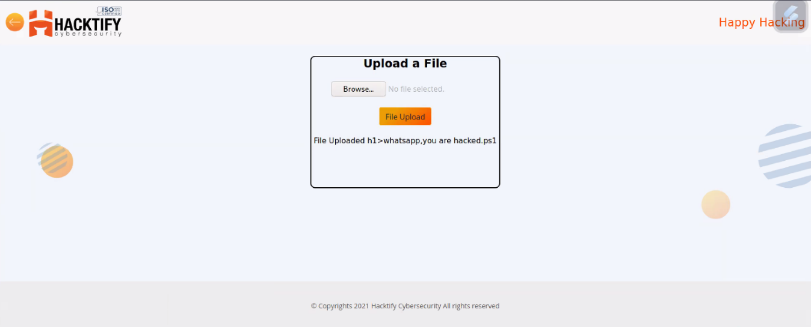
This section contains the proof of the above vulnerabilities as the screenshot of the vulnerability of the lab

    - File content and HTML Injection a perfect pair

Reference | Risk Rating
Sub-lab-4: File content and HTML Injection are a perfect pair | Medium
Tools Used
Google chrome
Vulnerability Description
HTML injection is a type of web security vulnerability that allows an attacker to inject malicious HTML code into a webpage. This can occur when user input is not properly validated or sanitized before being included in the webpage's output. Attackers can exploit HTML injection vulnerabilities to manipulate the appearance or functionality of the webpage, steal sensitive information such as login credentials or session cookies, or redirect users to malicious websites. This type of vulnerability can have serious consequences and requires proper input validation and output encoding to mitigate the risk.
How It Was Discovered
I found this vulnerability by just uploading malicious files in the file uploading section with different file extensions and containing malicious code in it.
Vulnerable URLs
https://labs.hacktify.in/HTML/ html_lab/lab_4/lab_4.php
Consequences of not Fixing the Issue
It can lead to taking down an entire website and the website will show wrong data content on
the website.
Suggested Countermeasures
- Comprehensive Input Validation and Sanitization
- Proper Output Escaping to Prevent Code Execution
- Educate developers on secure coding practices.
- Regularly audit and test for vulnerabilities.
References
- https://www.acunetix.com/vulnerabilities/web/html-injection/
- https://owasp.org/www-project-web-security-testing-guide/latest/4-Web_Application_Security_Testing/11-Client-side_Testing/03-Testing_for_HTML_Injection
- https://www.imperva.com/learn/application-security/html-injection/
Payload Used
<h1>You are Hacked</h1> in a text file and then uploaded over there

Proof of Concept

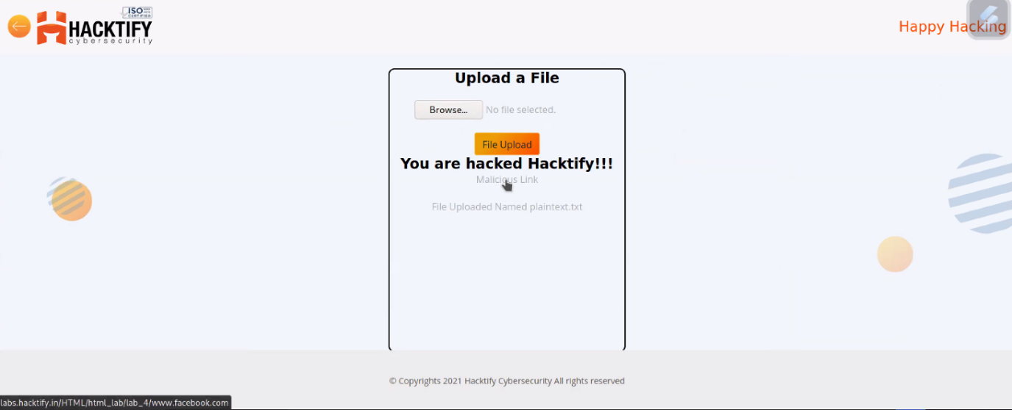
This section contains the proof of the above vulnerabilities as the screenshot of the vulnerability of the lab

    - Injecting HTML using URL

Reference | Risk Rating
Sub-lab-5: Injecting HTML using URL | Medium
Tools Used
Google chrome
Vulnerability Description
HTML injection is a type of web security vulnerability that allows an attacker to inject malicious HTML code into a webpage. This can occur when user input is not properly validated or sanitized before being included in the webpage's output. Attackers can exploit HTML injection vulnerabilities to manipulate the appearance or functionality of the webpage, steal sensitive information such as login credentials or session cookies, or redirect users to malicious websites. This type of vulnerability can have serious consequences and requires proper input validation and output encoding to mitigate the risk.
How It Was Discovered
I found this vulnerability by tampering the actual website of the code and injecting valid HTML code as malicious code or payload
Vulnerable URLs
https://labs.hacktify.in/HTML/ html_lab/lab_5/lab_5.php
Consequences of not Fixing the Issue
It can allow attackers to modify the URL and modify the web pages
Suggested Countermeasures
- Comprehensive Input Validation and Sanitization
- Proper Output Escaping to Prevent Code Execution
- Educate developers on secure coding practices.
- Regularly audit and test for vulnerabilities.
References
- https://www.acunetix.com/vulnerabilities/web/html-injection/
- https://owasp.org/www-project-web-security-testing-guide/latest/4-Web_Application_Security_Testing/11-Client-side_Testing/03-Testing_for_HTML_Injection
- https://www.imperva.com/learn/application-security/html-injection/
Payload Used
?<h1>Hacked Website</h1> in the URL

Proof of Concept

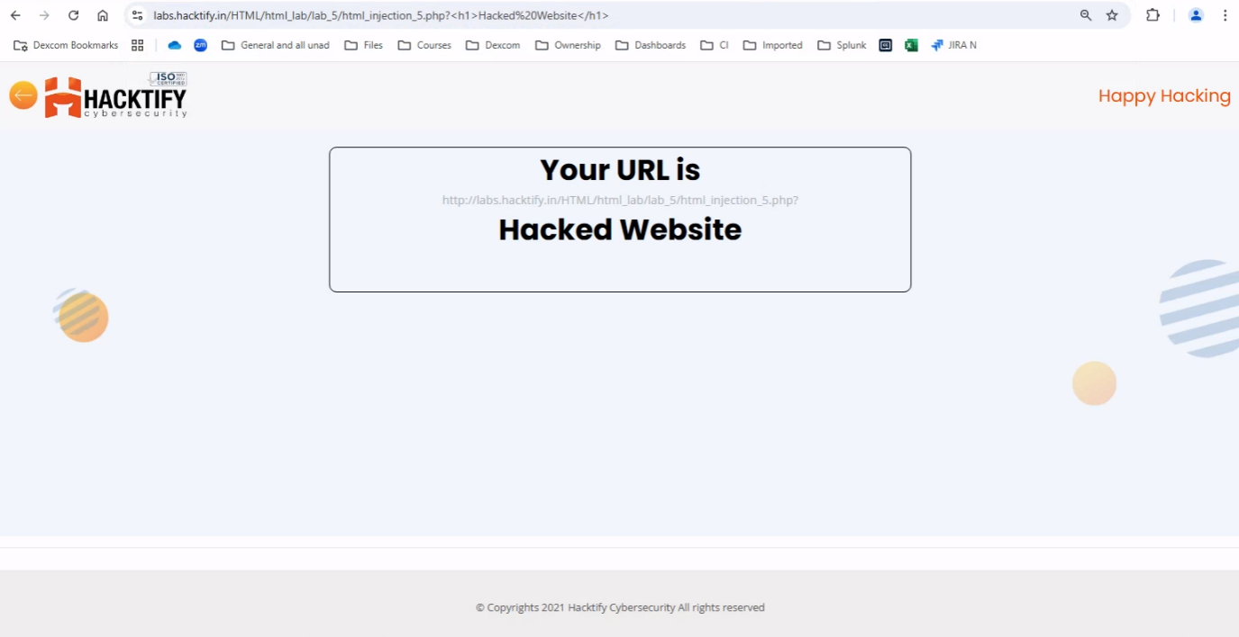
This section contains the proof of the above vulnerabilities as the screenshot of the vulnerability of the lab

    - Encode it

Reference | Risk Rating
Sub-lab-6: Encode it | High
Tools Used
Google chrome and URL encoder
Vulnerability Description
HTML injection is a type of web security vulnerability that allows an attacker to inject malicious HTML code into a webpage. This can occur when user input is not properly validated or sanitized before being included in the webpage's output. Attackers can exploit HTML injection vulnerabilities to manipulate the appearance or functionality of the webpage, steal sensitive information such as login credentials or session cookies, or redirect users to malicious websites. This type of vulnerability can have serious consequences and requires proper input validation and output encoding to mitigate the risk.
How It Was Discovered
I found this vulnerability by entering basic HTML valid code by encoding it into URL encoder
Vulnerable URLs
https://labs.hacktify.in/HTML/ html_lab/lab_6/lab_6.php
Consequences of not Fixing the Issue
This can lead to managing and accessing other web pages and it can lead to phishing other users.
Suggested Countermeasures
- Comprehensive Input Validation and Sanitization
- Proper Output Escaping to Prevent Code Execution
- Educate developers on secure coding practices.
- Regularly audit and test for vulnerabilities.
References
- https://www.acunetix.com/vulnerabilities/web/html-injection/
- https://owasp.org/www-project-web-security-testing-guide/latest/4-Web_Application_Security_Testing/11-Client-side_Testing/03-Testing_for_HTML_Injection
- https://www.imperva.com/learn/application-security/html-injection/
- https://www.urlencoder.org/
Payload Used
Plain Text - <h1?Hello bunny. You hacked it!!</h1>
Encoded Text - %3Ch1%3FHello%20bunny.%20You%20hacked%20it%21%21%3C%2Fh1

Proof of Concept

This section contains the proof of the above vulnerabilities as the screenshot of the vulnerability of the lab

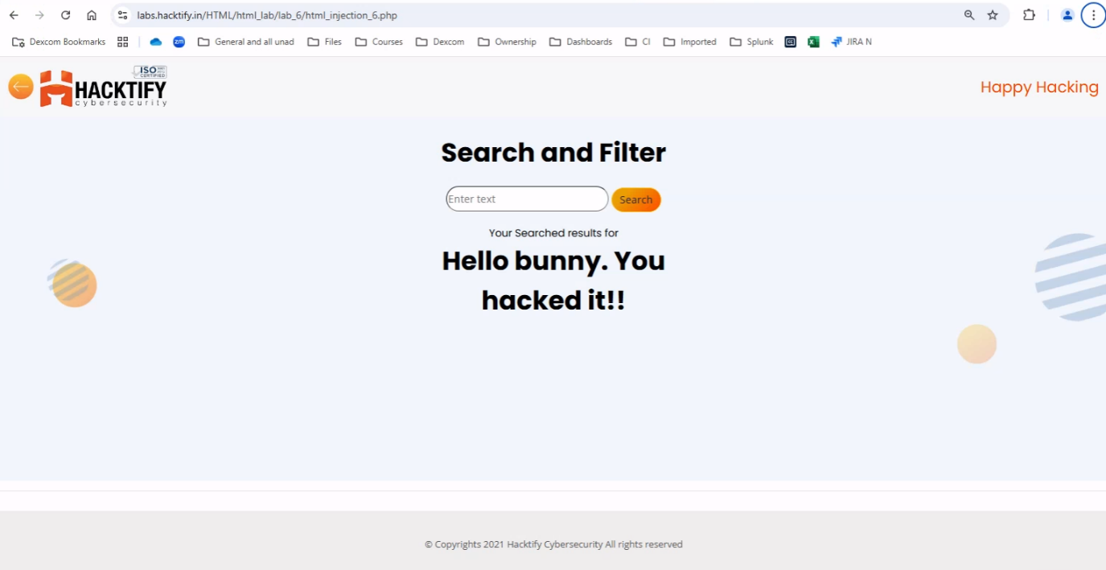

  - Cross-Site Scripting
    - Let’s do it!

Reference | Risk Rating
Sub-lab-1: Let’s Do IT! | Low
Tools Used
Google chrome
Vulnerability Description
Cross-site scripting (also known as XSS) is a web security vulnerability that allows an attacker to compromise the interactions that users have with a vulnerable application. Cross-site scripting vulnerabilities normally allow an attacker to masquerade as a victim user, to carry out any actions that the user is able to perform, and to access any of the user's data. If the victim user has privileged access within the application, then the attacker might be able to gain full control over all of the application's functionality and data.
How It Was Discovered
I found this vulnerability by entering simple javascript code into the client side reflection field, i.e., I successfully performed reflected xss.
Vulnerable URLs
labs.hacktify.in/HTML/xss_lab/lab_1/lab_1.php
Consequences of not Fixing the Issue
XSS enables an attacker to inject client-side code, so with this, an attacker will be able to capture client-side cookies which can capture account credentials of any user.
Suggested Countermeasures
- Comprehensive Input Validation and Sanitization
- Proper Output Escaping to Prevent Code Execution
- Configuring Content Security Policies (CSP) for Enhanced Protection
- Configure Essential HTTP Security Headers for Enhanced Protection
- Deploy a Web Application Firewall (WAF) to Block Malicious Payloads
- Educate developers on secure coding practices.
- Regularly audit and test for vulnerabilities.
References
- https://github.com/s0md3v/AwesomeXSS
- https://portswigger.net/web-security/cross-site-scripting
- https://owasp.org/www-community/attacks/xss/
- https://github.com/payloadbox/xss-payload-list
Payload Used
<script>alert(27)</script>

Proof of Concept

This section contains the proof of the above vulnerabilities as the screenshot of the vulnerability of the lab

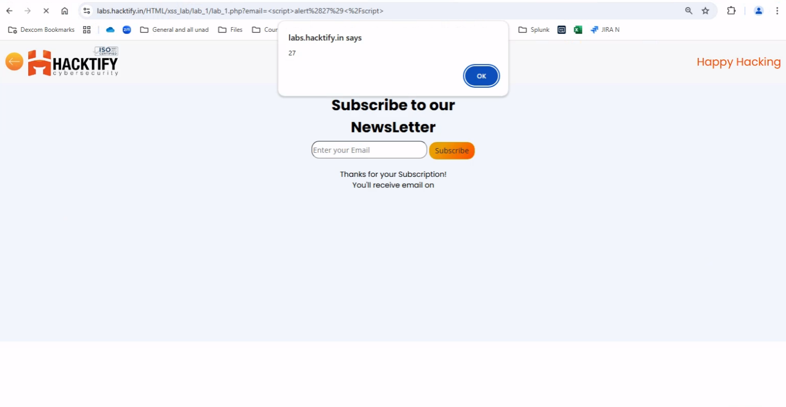
2.2. Balancing is important in life

Reference | Risk Rating
Sub-lab-2: Balancing is important in life | Low
Tools Used
Google chrome
Vulnerability Description
Cross-site scripting (also known as XSS) is a web security vulnerability that allows an attacker to compromise the interactions that users have with a vulnerable application. Cross-site scripting vulnerabilities normally allow an attacker to masquerade as a victim user, to carry out any actions that the user is able to perform, and to access any of the user's data. If the victim user has privileged access within the application, then the attacker might be able to gain full control over all of the application's functionality and data.
How It Was Discovered
I found this vulnerability by modifying the URL after getting valid output as actually developed. Also, it will allow an attacker to carry out any action that the user is able to perform.
Vulnerable URLs
labs.hacktify.in/HTML/xss_lab/lab_2/lab_2.php
Consequences of not Fixing the Issue
Carry out any action that the user can perform.
Suggested Countermeasures
- Comprehensive Input Validation and Sanitization
- Proper Output Escaping to Prevent Code Execution
- Configuring Content Security Policies (CSP) for Enhanced Protection
- Configure Essential HTTP Security Headers for Enhanced Protection
- Deploy a Web Application Firewall (WAF) to Block Malicious Payloads
- Educate developers on secure coding practices.
- Regularly audit and test for vulnerabilities.
References
- https://github.com/s0md3v/AwesomeXSS
- https://portswigger.net/web-security/cross-site-scripting
- https://owasp.org/www-community/attacks/xss/
- https://github.com/payloadbox/xss-payload-list
Payload Used
"/><script>alert("Hacked by Bunny")</script>

Proof of Concept

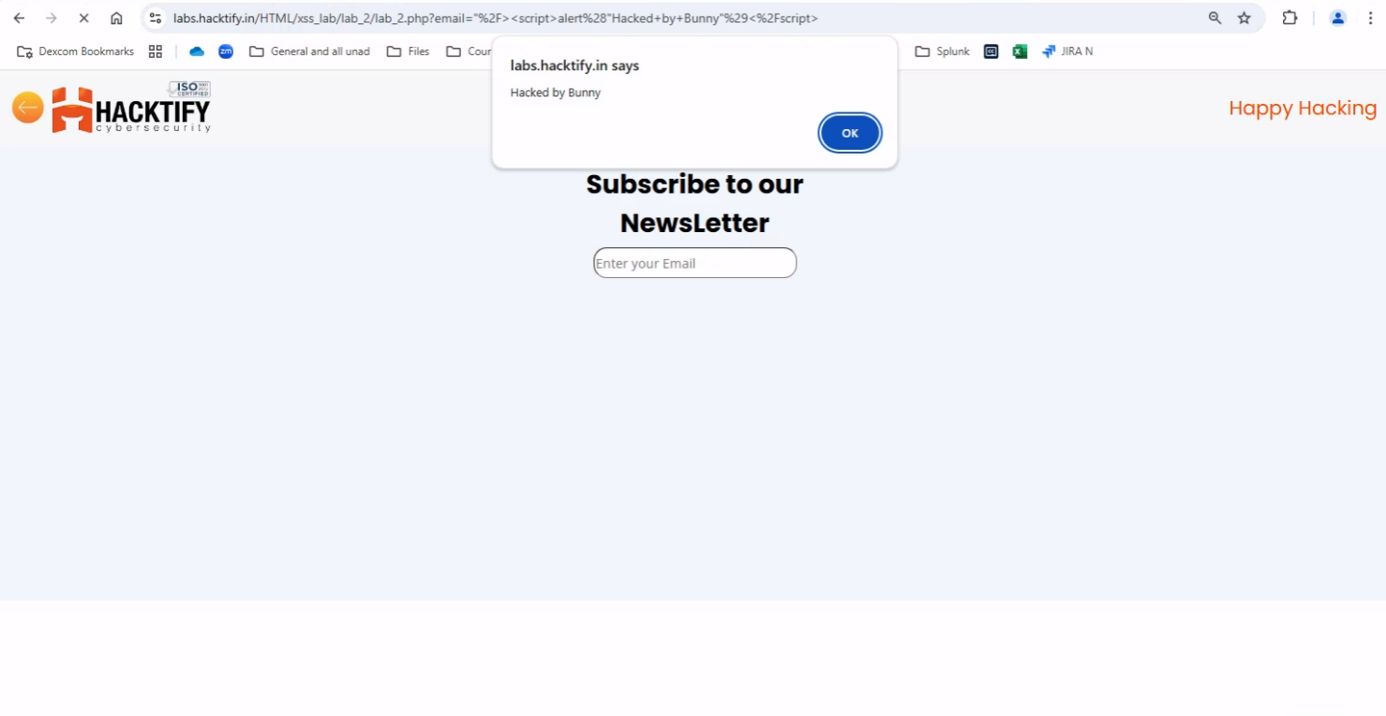
This section contains the proof of the above vulnerabilities as the screenshot of the vulnerability of the lab

2.3. XSS is everywhere!

Reference | Risk Rating
Sub-lab-3: XSS is everywhere! | Low
Tools Used
Google chrome
Vulnerability Description
Cross-site scripting (also known as XSS) is a web security vulnerability that allows an attacker to compromise the interactions that users have with a vulnerable application. Cross-site scripting vulnerabilities normally allow an attacker to masquerade as a victim user, to carry out any actions that the user is able to perform, and to access any of the user's data. If the victim user has privileged access within the application, then the attacker might be able to gain full control over all of the application's functionality and data.
How It Was Discovered
I found this vulnerability by modifying the URL after getting valid output as actually developed. Here, the developer has given validation while developing this web page as the text field must contain a valid email address which will end with “@gmail.com”. If any other input is entered, then an error message will display called “Enter a valid email address”. So, to bypass this I simple inserted my payload which will end with provided validation for input, i.e., “@gmail.com”
Vulnerable URLs
labs.hacktify.in/HTML/xss_lab/lab_3/lab_3.php
Consequences of not Fixing the Issue
Carry out any action that the user can perform.
Suggested Countermeasures
- Comprehensive Input Validation and Sanitization
- Proper Output Escaping to Prevent Code Execution
- Configuring Content Security Policies (CSP) for Enhanced Protection
- Configure Essential HTTP Security Headers for Enhanced Protection
- Deploy a Web Application Firewall (WAF) to Block Malicious Payloads
- Educate developers on secure coding practices.
- Regularly audit and test for vulnerabilities.
References
- https://github.com/s0md3v/AwesomeXSS
- https://portswigger.net/web-security/cross-site-scripting
- https://owasp.org/www-community/attacks/xss/
- https://github.com/payloadbox/xss-payload-list
Payload Used
@gmail.com<script>alert("Hello From Bunny in Lab 3")</script>

Proof of Concept

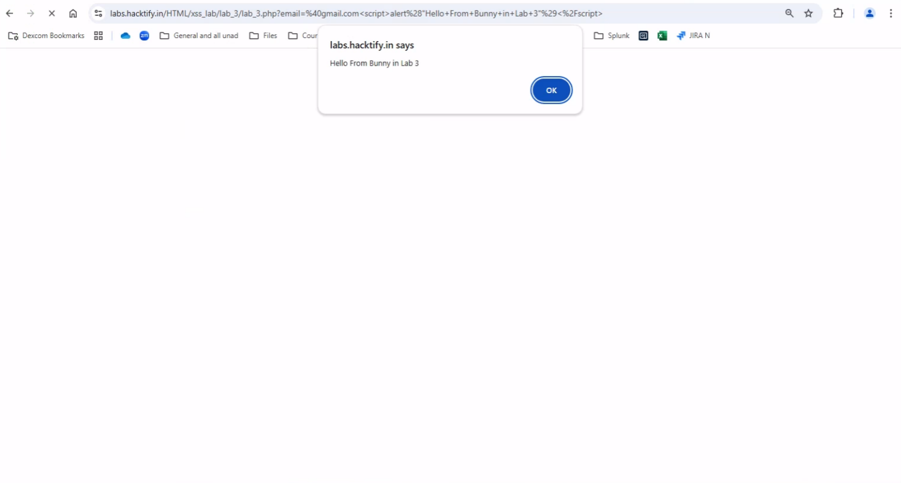
This section contains the proof of the above vulnerabilities as the screenshot of the vulnerability of the lab

2.4. Alternatives are a must!

Reference | Risk Rating
Sub-lab-4: Alternatives are a must | Medium
Tools Used
Google chrome
Vulnerability Description
Cross-site scripting (also known as XSS) is a web security vulnerability that allows an attacker to compromise the interactions that users have with a vulnerable application. Cross-site scripting vulnerabilities normally allow an attacker to masquerade as a victim user, to carry out any actions that the user is able to perform, and to access any of the user's data. If the victim user has privileged access within the application, then the attacker might be able to gain full control over all of the application's functionality and data.
How It Was Discovered
I found this vulnerability by modifying the URL after getting valid output as actually developed. But, here the developer has sanitized the tag which is commonly used in JavaScript, i.e., alert(). So, to bypass this situation, I used the confirm() tag and I successfully got what I expected. Also, I am able to successfully run prompt() tag instead of alert() and alternative of confirm()
Vulnerable URLs
labs.hacktify.in/HTML/xss_lab/lab_4/lab_4.php
Consequences of not Fixing the Issue
Carry out any action that the user can perform.
Suggested Countermeasures
- Comprehensive Input Validation and Sanitization
- Proper Output Escaping to Prevent Code Execution
- Configuring Content Security Policies (CSP) for Enhanced Protection
- Configure Essential HTTP Security Headers for Enhanced Protection
- Deploy a Web Application Firewall (WAF) to Block Malicious Payloads
- Educate developers on secure coding practices.
- Regularly audit and test for vulnerabilities.
References
- https://github.com/s0md3v/AwesomeXSS
- https://portswigger.net/web-security/cross-site-scripting
- https://owasp.org/www-community/attacks/xss/
- https://github.com/payloadbox/xss-payload-list
Payload Used
"/><script>confirm("This is also hacked by bunny")</script>@gmail.com

Proof of Concept

This section contains the proof of the above vulnerabilities as the screenshot of the vulnerability of the lab

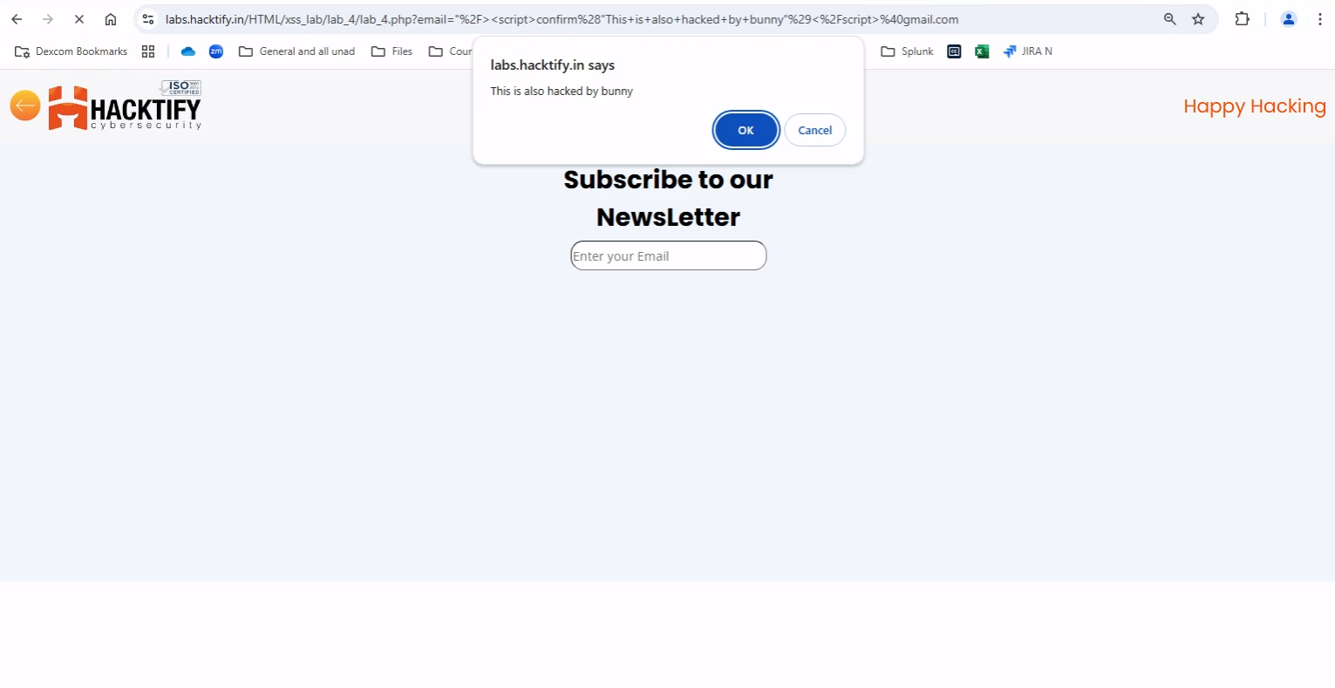

2.5. Developer hates script!

Reference | Risk Rating
Sub-lab-5: Developers hate scripts! | High
Tools Used
Google chrome
Vulnerability Description
Cross-site scripting (also known as XSS) is a web security vulnerability that allows an attacker to compromise the interactions that users have with a vulnerable application. Cross-site scripting vulnerabilities normally allow an attacker to masquerade as a victim user, to carry out any actions that the user is able to perform, and to access any of the user's data. If the victim user has privileged access within the application, then the attacker might be able to gain full control over all of the application's functionality and data.
How It Was Discovered
I found this vulnerability by using different javascript tags like <img>, <svg>, etc
Vulnerable URLs
labs.hacktify.in/HTML/xss_lab/lab_5/lab_5.php
Consequences of not Fixing the Issue
Carry out any action that the user can perform.
Suggested Countermeasures
- Comprehensive Input Validation and Sanitization
- Proper Output Escaping to Prevent Code Execution
- Configuring Content Security Policies (CSP) for Enhanced Protection
- Configure Essential HTTP Security Headers for Enhanced Protection
- Deploy a Web Application Firewall (WAF) to Block Malicious Payloads
- Educate developers on secure coding practices.
- Regularly audit and test for vulnerabilities.
References
- https://github.com/s0md3v/AwesomeXSS
- https://portswigger.net/web-security/cross-site-scripting
- https://owasp.org/www-community/attacks/xss/
- https://github.com/payloadbox/xss-payload-list
Payload Used
"/><img src=bunny onerror=alert(27) >

Proof of Concept

This section contains the proof of the above vulnerabilities as the screenshot of the vulnerability of the lab

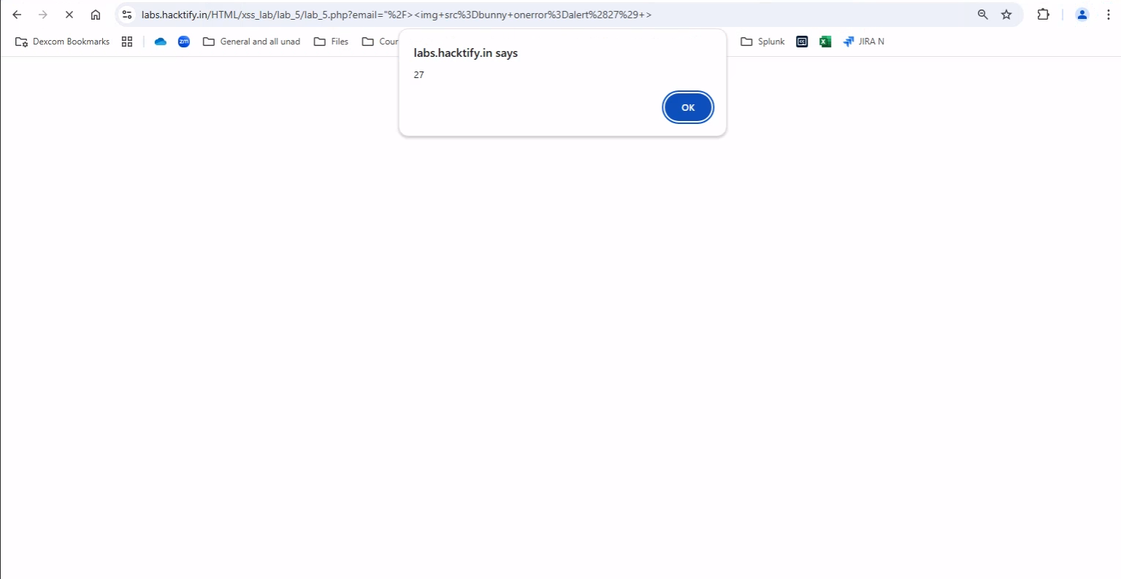

2.6. Change the variation!

Reference | Risk Rating
Sub-lab-6: Change the variation! | High
Tools Used
Google chrome
Vulnerability Description
Cross-site scripting (also known as XSS) is a web security vulnerability that allows an attacker to compromise the interactions that users have with a vulnerable application. Cross-site scripting vulnerabilities normally allow an attacker to masquerade as a victim user, to carry out any actions that the user is able to perform, and to access any of the user's data. If the victim user has privileged access within the application, then the attacker might be able to gain full control over all of the application's functionality and data.
How It Was Discovered
I found this vulnerability by merging two different tags within a single command as payload to bypass the situation which the developer has created. I used, <script> tag in which I used <svg> tag to bypass it
Vulnerable URLs
labs.hacktify.in/HTML/xss_lab/lab_6/lab_6.php
Consequences of not Fixing the Issue
Carry out any action that the user can perform.
Suggested Countermeasures
- Comprehensive Input Validation and Sanitization
- Proper Output Escaping to Prevent Code Execution
- Configuring Content Security Policies (CSP) for Enhanced Protection
- Configure Essential HTTP Security Headers for Enhanced Protection
- Deploy a Web Application Firewall (WAF) to Block Malicious Payloads
- Educate developers on secure coding practices.
- Regularly audit and test for vulnerabilities.
References
- https://github.com/s0md3v/AwesomeXSS
- https://portswigger.net/web-security/cross-site-scripting
- https://owasp.org/www-community/attacks/xss/
- https://github.com/payloadbox/xss-payload-list
Payload Used
"/><script>confirm(<svg xmlns="https://www.theyfuckerme.com" onload=alert(document.domain)>) </script>

Proof of Concept

This section contains the proof of the above vulnerabilities as the screenshot of the vulnerability of the lab

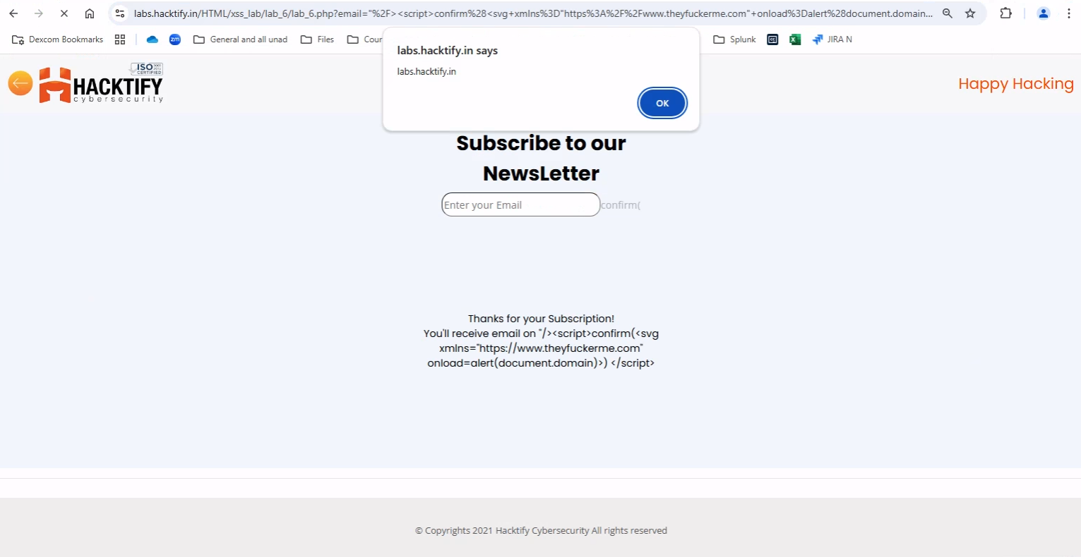

2.7. Encoding is the key?

Reference | Risk Rating
Sub-lab-7: Encoding is the key? | Medium
Tools Used
Google chrome and URL encoder
Vulnerability Description
Cross-site scripting (also known as XSS) is a web security vulnerability that allows an attacker to compromise the interactions that users have with a vulnerable application. Cross-site scripting vulnerabilities normally allow an attacker to masquerade as a victim user, to carry out any actions that the user is able to perform, and to access any of the user's data. If the victim user has privileged access within the application, then the attacker might be able to gain full control over all of the application's functionality and data.
How It Was Discovered
This vulnerability was found by URL encoding a simple javascript command with the help of URL encoder
Vulnerable URLs
labs.hacktify.in/HTML/xss_lab/lab_7/lab_7.php
Consequences of not Fixing the Issue
Carry out any action that the user can perform.
Suggested Countermeasures
- Comprehensive Input Validation and Sanitization
- Proper Output Escaping to Prevent Code Execution
- Configuring Content Security Policies (CSP) for Enhanced Protection
- Configure Essential HTTP Security Headers for Enhanced Protection
- Deploy a Web Application Firewall (WAF) to Block Malicious Payloads
- Educate developers on secure coding practices.
- Regularly audit and test for vulnerabilities.
References
- https://github.com/s0md3v/AwesomeXSS
- https://portswigger.net/web-security/cross-site-scripting
- https://owasp.org/www-community/attacks/xss/
- https://github.com/payloadbox/xss-payload-list
- https://www.urlencoder.org/
Payload Used
Plain Text - "/><script>alert("your love, BUNNY!!")</script>
Encoded Payload - %22%2F%3E%3Cscript%3Ealert%28%22your%20love%2C%20BUNNY%21%21%22%29%3C%2Fscript%3E

Proof of Concept

This section contains the proof of the above vulnerabilities as the screenshot of the vulnerability of the lab

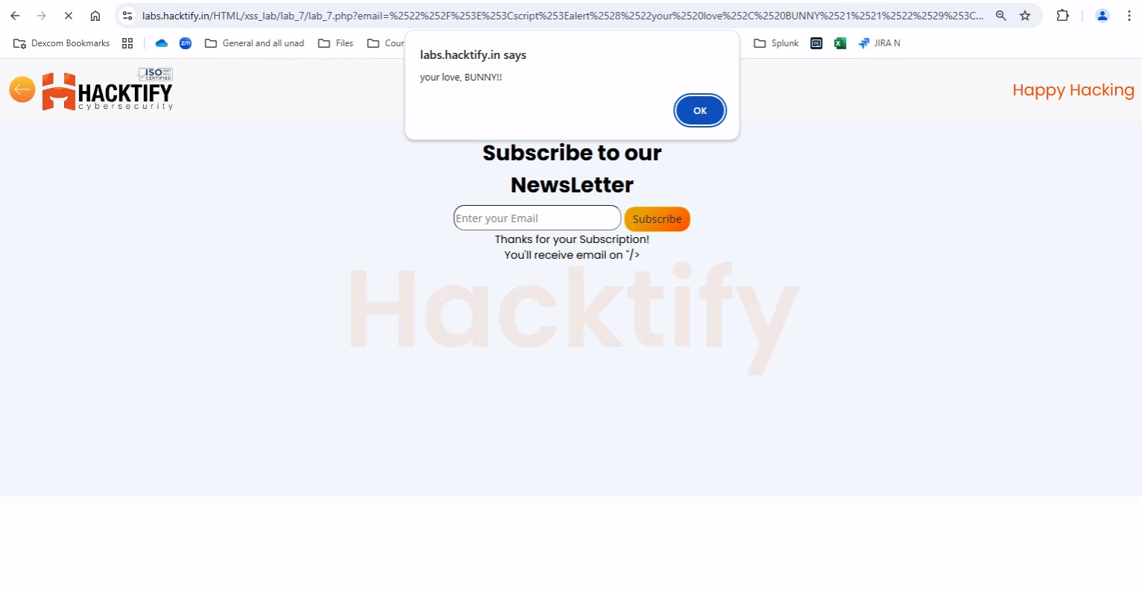

2.8. XSS with file upload (file name)

Reference | Risk Rating
Sub-lab-8: XSS with file upload (file name) | Low
Tools Used
Google chrome and Burp Suite
Vulnerability Description
Cross-site scripting (also known as XSS) is a web security vulnerability that allows an attacker to compromise the interactions that users have with a vulnerable application. Cross-site scripting vulnerabilities normally allow an attacker to masquerade as a victim user, to carry out any actions that the user is able to perform, and to access any of the user's data. If the victim user has privileged access within the application, then the attacker might be able to gain full control over all of the application's functionality and data.
How It Was Discovered
I found this vulnerability by intercepting a file upload request onto Burp Suite tool and renaming the file name to insert payload into filename to bypass all the validation to load payload into the web pages and database to store payload into it.
Vulnerable URLs
labs.hacktify.in/HTML/xss_lab/lab_8/lab_8.php
Consequences of not Fixing the Issue
Carry out any action that the user can perform.
Suggested Countermeasures
- Comprehensive Input Validation and Sanitization
- Proper Output Escaping to Prevent Code Execution
- Configuring Content Security Policies (CSP) for Enhanced Protection
- Configure Essential HTTP Security Headers for Enhanced Protection
- Deploy a Web Application Firewall (WAF) to Block Malicious Payloads
- Educate developers on secure coding practices.
- Regularly audit and test for vulnerabilities.
References
- https://github.com/s0md3v/AwesomeXSS
- https://portswigger.net/web-security/cross-site-scripting
- https://owasp.org/www-community/attacks/xss/
- https://github.com/payloadbox/xss-payload-list
Payload Used
"/><img src=bunny onerror=alert(‘he’) >

Proof of Concept

This section contains the proof of the above vulnerabilities as the screenshot of the vulnerability of the lab

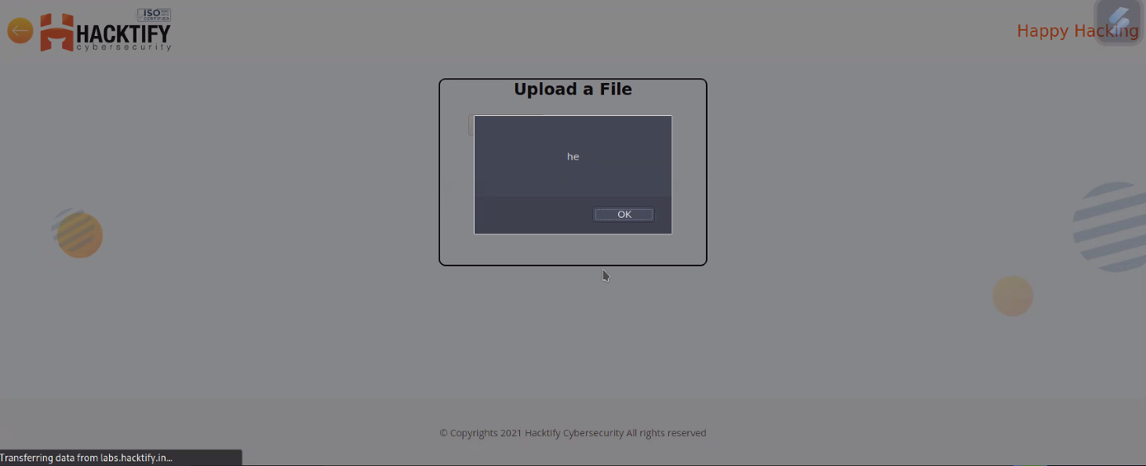

2.9. XSS with file upload (file content)

Reference | Risk Rating
Sub-lab-9: XSS with file upload (file content) | Medium
Tools Used
Google chrome
Vulnerability Description
Cross-site scripting (also known as XSS) is a web security vulnerability that allows an attacker to compromise the interactions that users have with a vulnerable application. Cross-site scripting vulnerabilities normally allow an attacker to masquerade as a victim user, to carry out any actions that the user is able to perform, and to access any of the user's data. If the victim user has privileged access within the application, then the attacker might be able to gain full control over all of the application's functionality and data.
How It Was Discovered
I found this vulnerability by uploading a malicious code file into the file upload section. In malicious code, I used <script> tag to design a malicious code.
Vulnerable URLs
labs.hacktify.in/HTML/xss_lab/lab_9/lab_9.php
Consequences of not Fixing the Issue
Carry out any action that the user can perform.
Suggested Countermeasures
- Comprehensive Input Validation and Sanitization
- Proper Output Escaping to Prevent Code Execution
- Configuring Content Security Policies (CSP) for Enhanced Protection
- Configure Essential HTTP Security Headers for Enhanced Protection
- Deploy a Web Application Firewall (WAF) to Block Malicious Payloads
- Educate developers on secure coding practices.
- Regularly audit and test for vulnerabilities.
References
- https://github.com/s0md3v/AwesomeXSS
- https://portswigger.net/web-security/cross-site-scripting
- https://owasp.org/www-community/attacks/xss/
- https://github.com/payloadbox/xss-payload-list
Payload Used
<script>alert(document.domain)</script>

Proof of Concept

This section contains the proof of the above vulnerabilities as the screenshot of the vulnerability of the lab

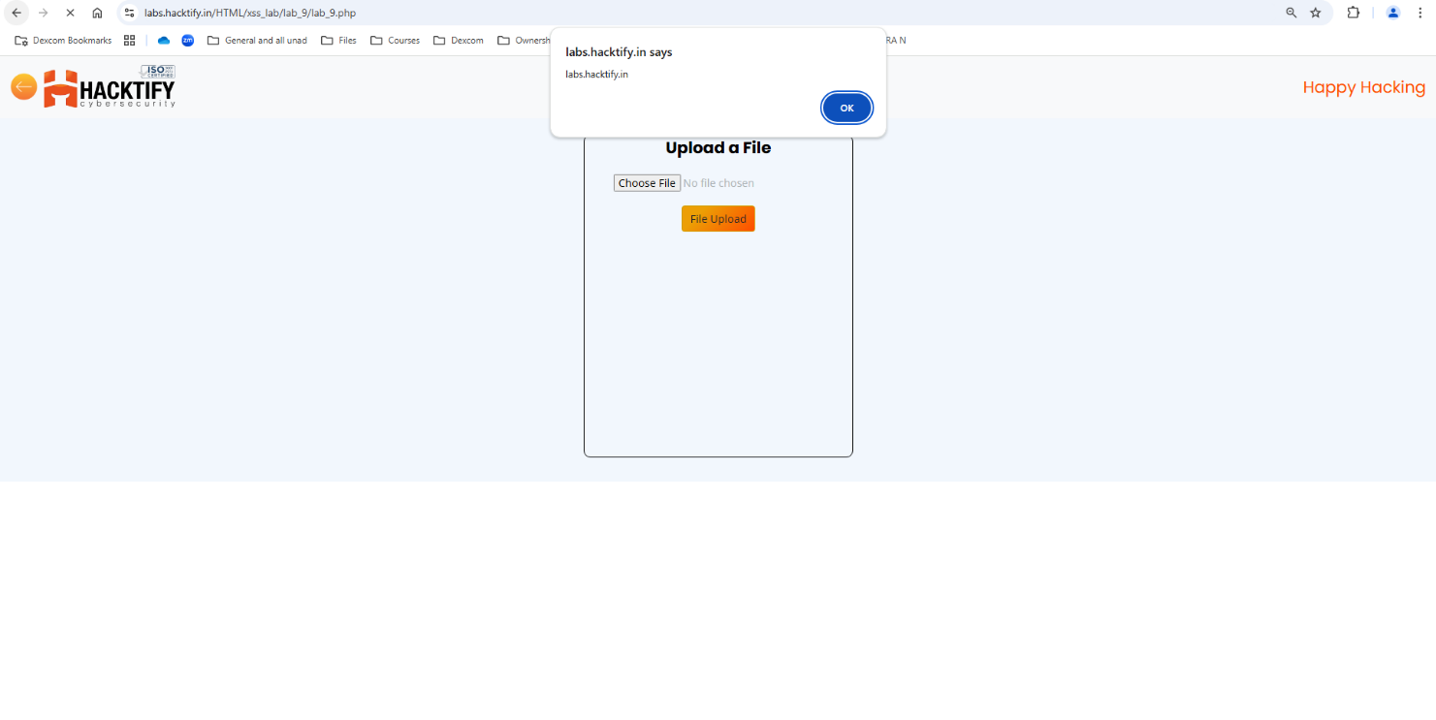

2.10. Stored Everywhere

Reference | Risk Rating
Sub-lab-10: Stored Everywhere | Low
Tools Used
Google chrome
Vulnerability Description
Cross-site scripting (also known as XSS) is a web security vulnerability that allows an attacker to compromise the interactions that users have with a vulnerable application. Cross-site scripting vulnerabilities normally allow an attacker to masquerade as a victim user, to carry out any actions that the user is able to perform, and to access any of the user's data. If the victim user has privileged access within the application, then the attacker might be able to gain full control over all of the application's functionality and data.
How It Was Discovered
I found this vulnerability by registering myself into register web page. I inserted a simple <script> tag in all fields which are required to fill for registration. After registration, I tried logging in into the webpage and after the login request, I was able to verify that I successfully implemented a stored XSS attack. Here, these credentials will be stored into the database which can affect other used credentials as well as other database related features.
Vulnerable URLs
labs.hacktify.in/HTML/xss_lab/lab_10/lab_10.php
Consequences of not Fixing the Issue
Carry out any action that the user can perform.
Suggested Countermeasures
- Comprehensive Input Validation and Sanitization
- Proper Output Escaping to Prevent Code Execution
- Configuring Content Security Policies (CSP) for Enhanced Protection
- Configure Essential HTTP Security Headers for Enhanced Protection
- Deploy a Web Application Firewall (WAF) to Block Malicious Payloads
- Educate developers on secure coding practices.
- Regularly audit and test for vulnerabilities.
References
- https://github.com/s0md3v/AwesomeXSS
- https://portswigger.net/web-security/cross-site-scripting
- https://owasp.org/www-community/attacks/xss/
- https://github.com/payloadbox/xss-payload-list
Payload Used
- "/><script>alert("Issue in FNAME")</script>
- "/><script>alert("Issue in LNAME")</script>
- "/><script>alert("Issue in EMAIL")</script>
- "/><script>alert("Issue in PASS")</script>

Proof of Concept

This section contains the proof of the above vulnerabilities as the screenshot of the vulnerability of the lab

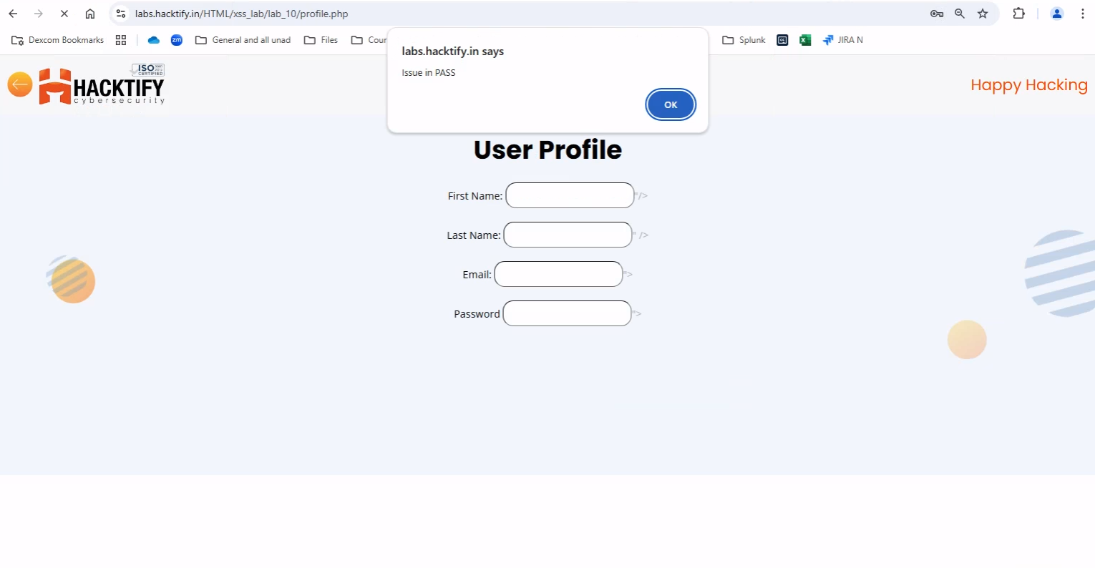

2.11. DOM’s are Love

Reference | Risk Rating
DOM’s are Love | High
Tools Used
Google chrome
Vulnerability Description
Cross-site scripting (also known as XSS) is a web security vulnerability that allows an attacker to compromise the interactions that users have with a vulnerable application. Cross-site scripting vulnerabilities normally allow an attacker to masquerade as a victim user, to carry out any actions that the user is able to perform, and to access any of the user's data. If the victim user has privileged access within the application, then the attacker might be able to gain full control over all of the application's functionality and data.
How It Was Discovered
I found this vulnerability by inspecting the source code of the web page and finding out what variables are used in this section. And later on, tried to load payload using <img> tag.
Vulnerable URLs
labs.hacktify.in/HTML/xss_lab/lab_11/lab_11.php
Consequences of not Fixing the Issue
Carry out any action that the user can perform.
Suggested Countermeasures
- Comprehensive Input Validation and Sanitization
- Proper Output Escaping to Prevent Code Execution
- Configuring Content Security Policies (CSP) for Enhanced Protection
- Configure Essential HTTP Security Headers for Enhanced Protection
- Deploy a Web Application Firewall (WAF) to Block Malicious Payloads
- Educate developers on secure coding practices.
- Regularly audit and test for vulnerabilities.
References
- https://github.com/s0md3v/AwesomeXSS
- https://portswigger.net/web-security/cross-site-scripting
- https://owasp.org/www-community/attacks/xss/
- https://github.com/payloadbox/xss-payload-list
Payload Used
Payload - name=bunny<img src=bugs onerror=alert("buggeebunny")>
URL - https://labs.hacktify.in/HTML/xss_lab/lab_11/lab_11.php?name=bunny%3Cimg%20src=bugs%20onerror=alert(%22buggeebunny%22)%3E

Proof of Concept

This section contains the proof of the above vulnerabilities as the screenshot of the vulnerability of the lab

